Scenario 1: Test to make sure that a user can add a new product to the system.

Start on the main screen of the Store Database Management System

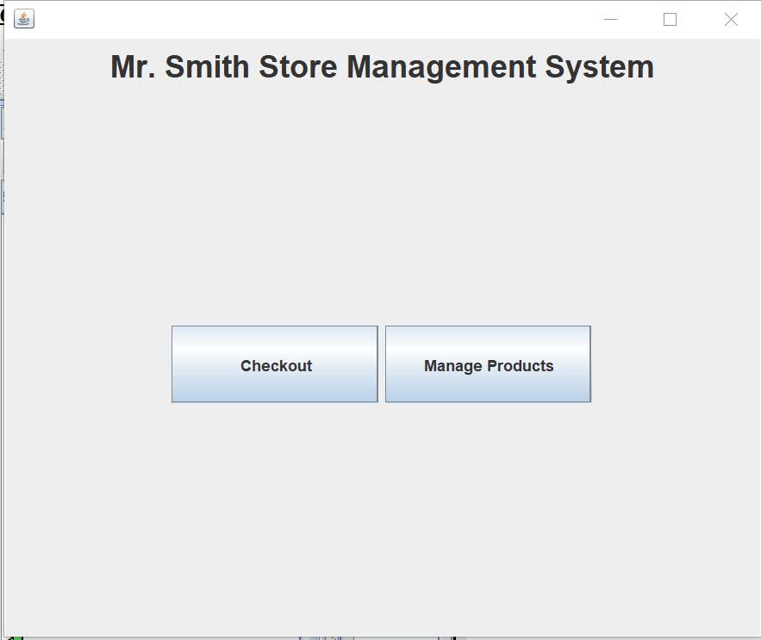

Step 1: Choose “Manage Products” from the main screen. This will open our Product View screen below:

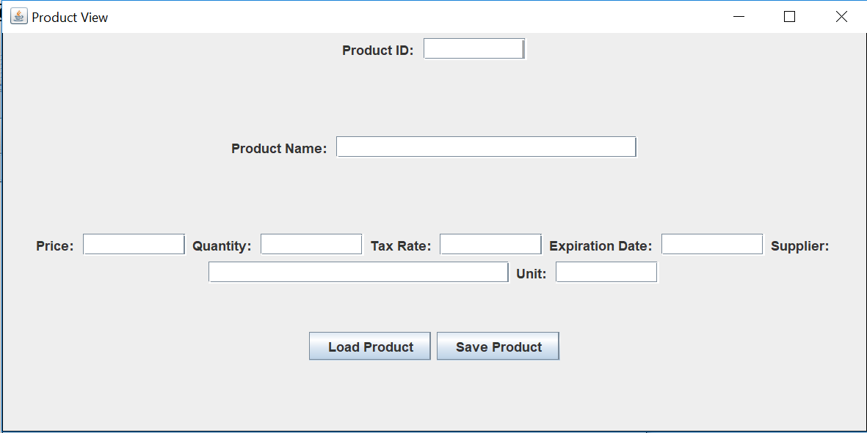

Step 2: Fill in all of the empty text fields with the new product information

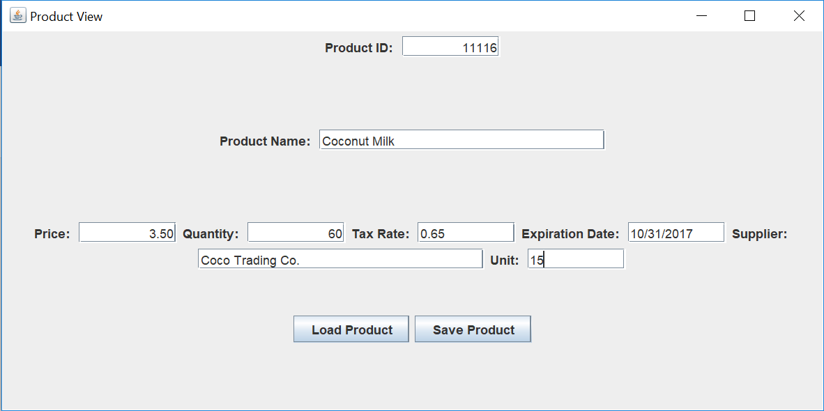

Step 3: Select “Save Product” in the Product View window

Step 4: In order to check to make sure that the add function truly works, we can look in the

database and see that it did get added.

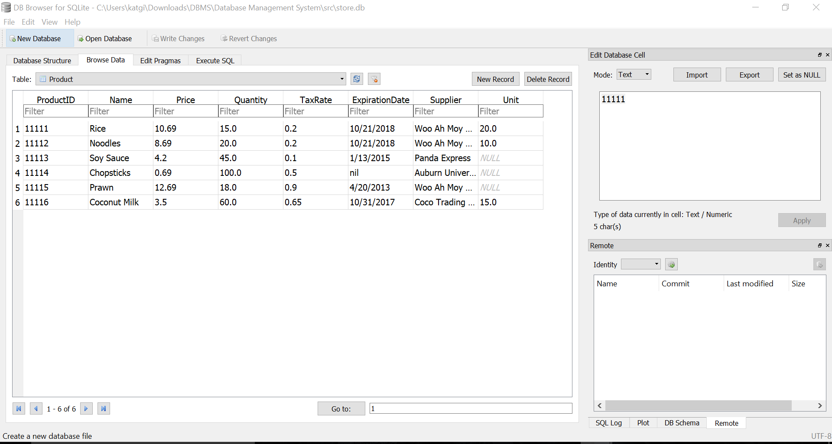

Scenario 2: Test to make sure that a user can update an already existing product.

Start on the main screen of the Store Database Management System



Step 1: Choose “Manage Products” from the main screen. This will open our Product View screen below:



Step 2: Load an already existing product into the text fields by typing in its product ID and selecting “Load Product”

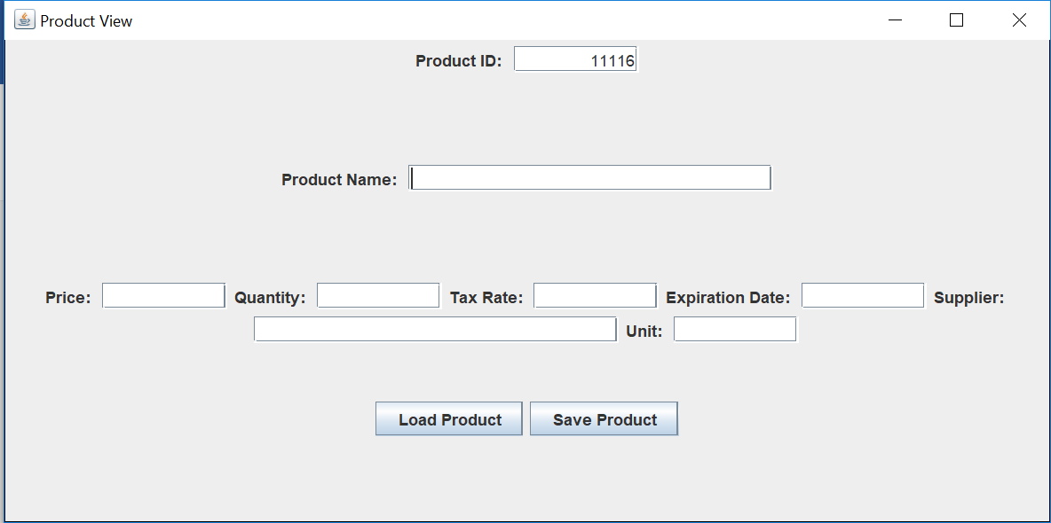

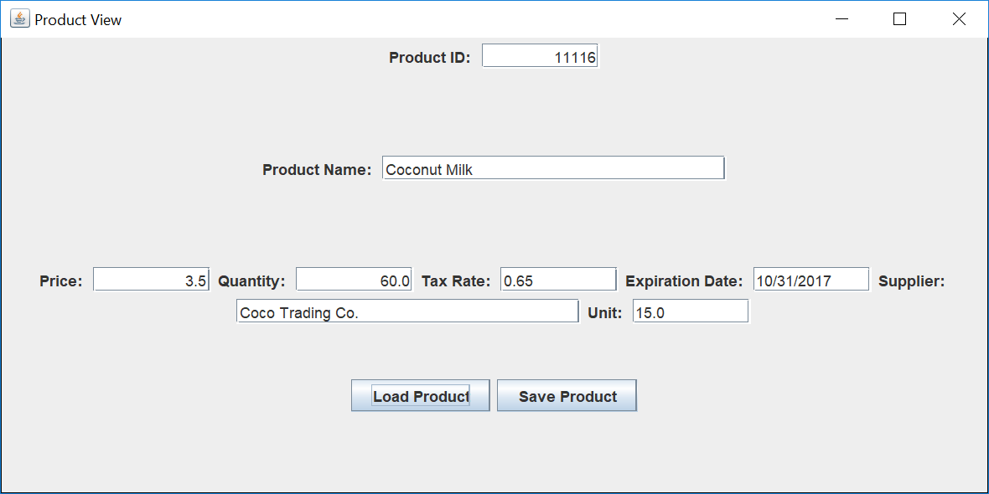

Step 3: Make the necessary changes to the product information.

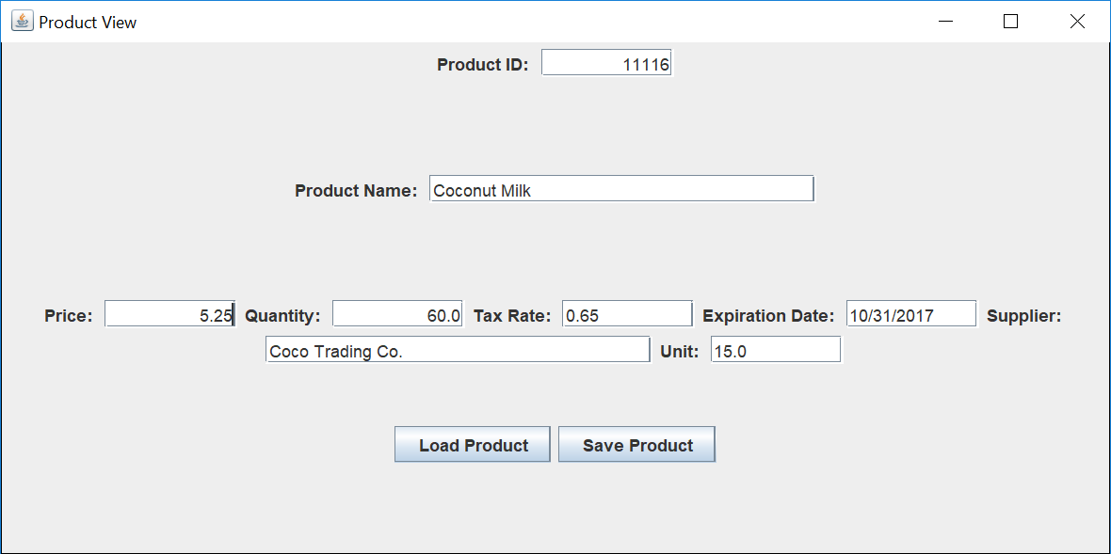

Step 4: Save the changes made to the product by selecting “Save Product”

Step 5: In order to check to make sure that the product information was updated, we can look in the database and see that Coconut Milk’s price did get changed from $3.50 to $5.25.

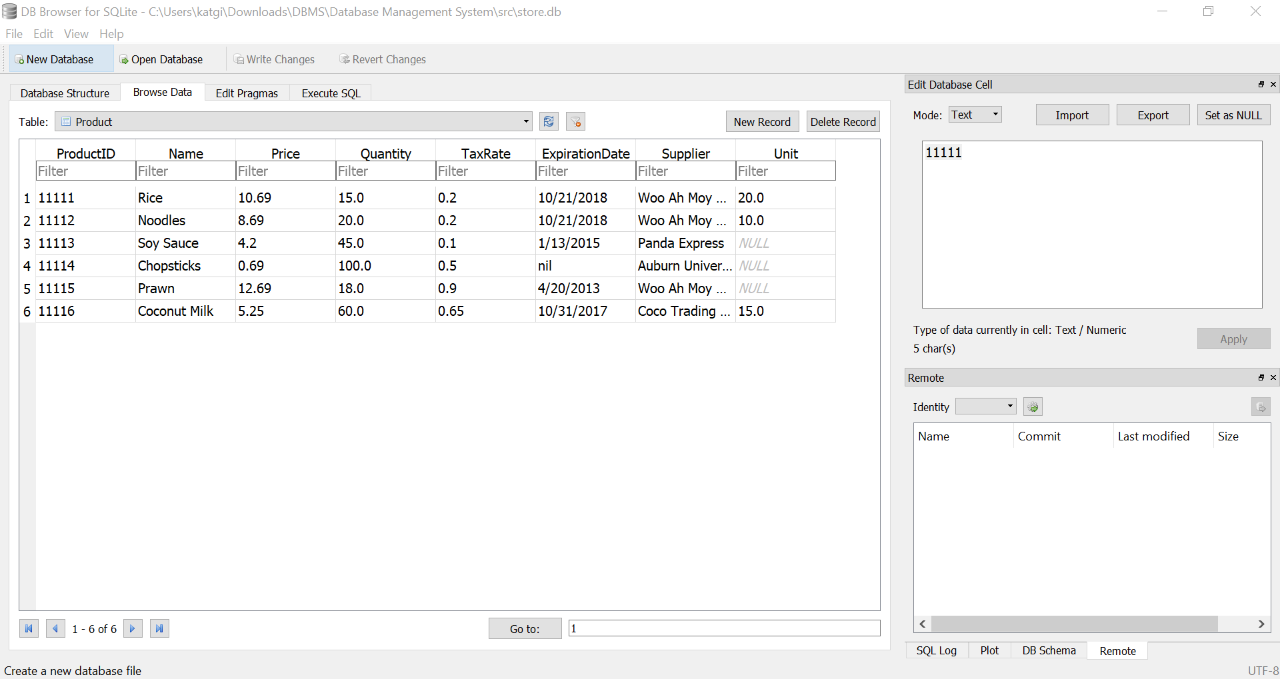

Scenario 3: Test to make sure that a user can check out all of the items a customer wishes to purchase.

Start on the main screen of the Store Database Management System



Step 1: Choose “Checkout” from the main screen. This will open our Checkout View screen below:

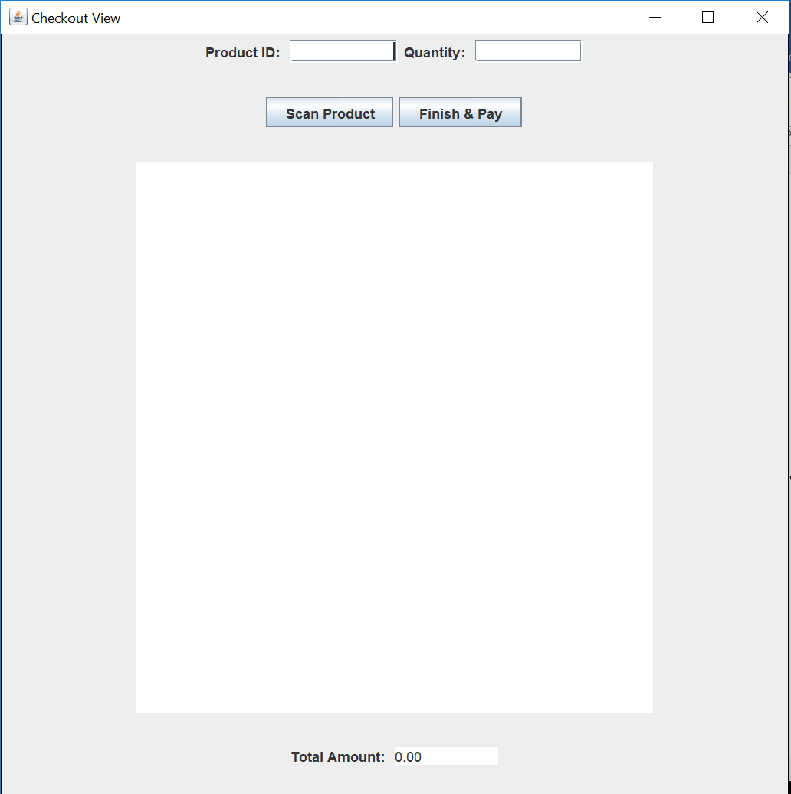

Step 2: Add the products that the customer wishes to check out by putting in the product ID and the quantity of that item.

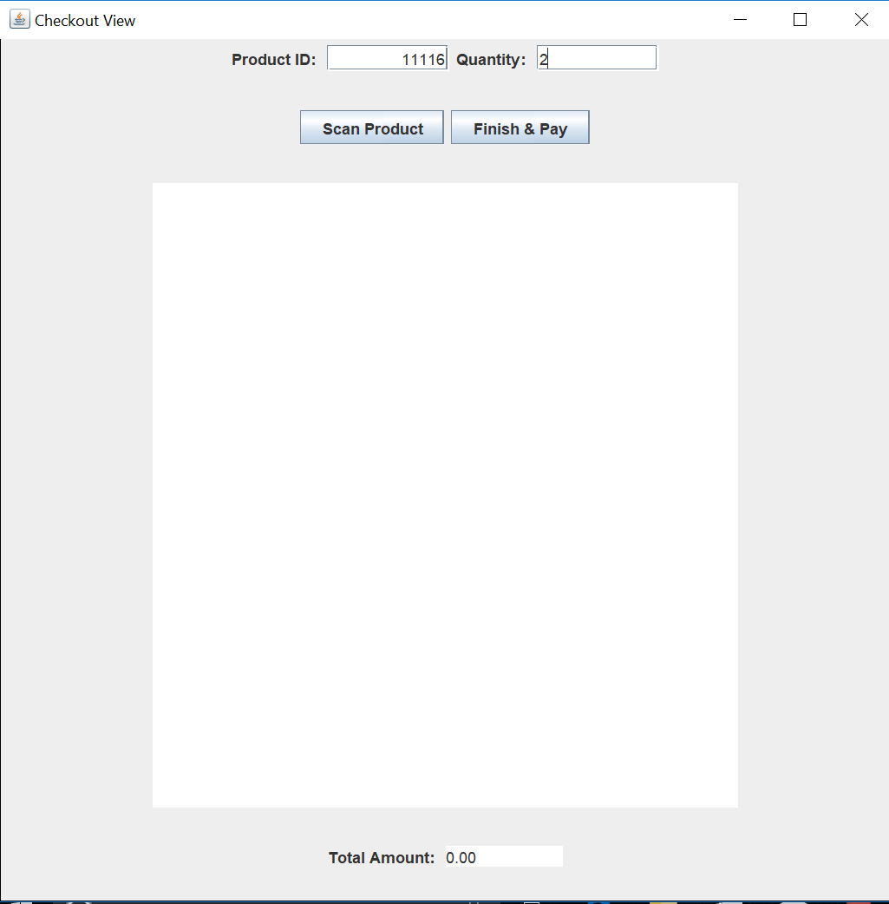

Step 3: Select “Scan Product” and that product will be added to the checkout list.

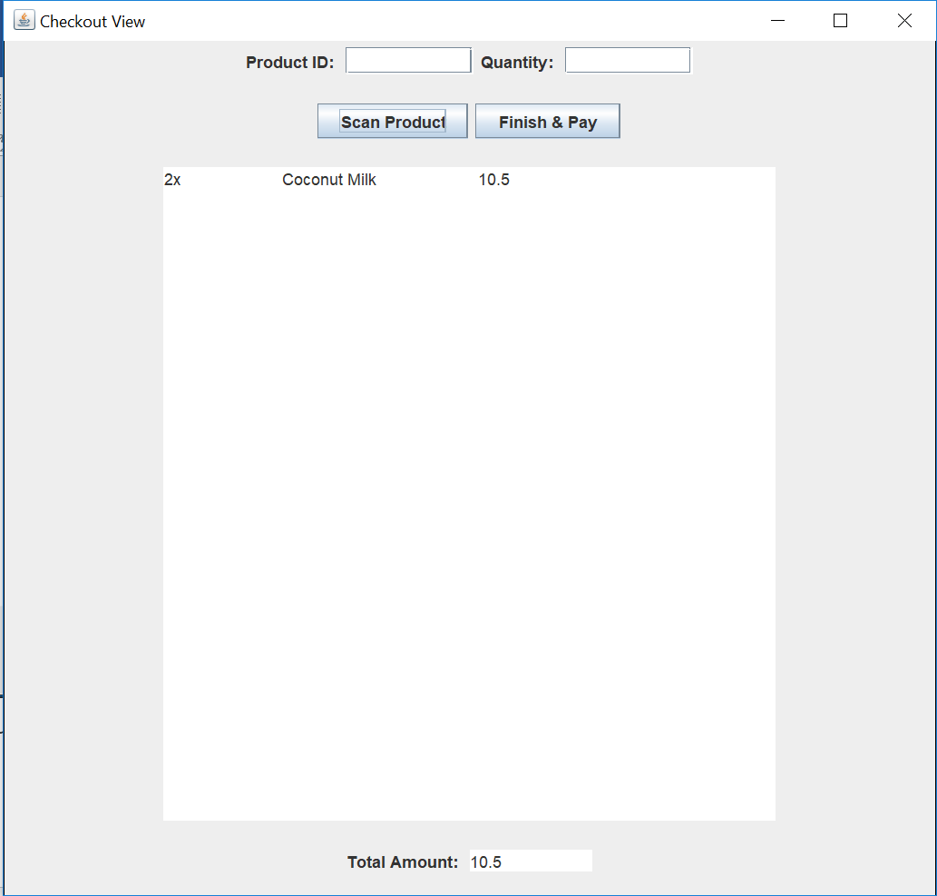

Step 4: Continue scanning products until the order is complete.

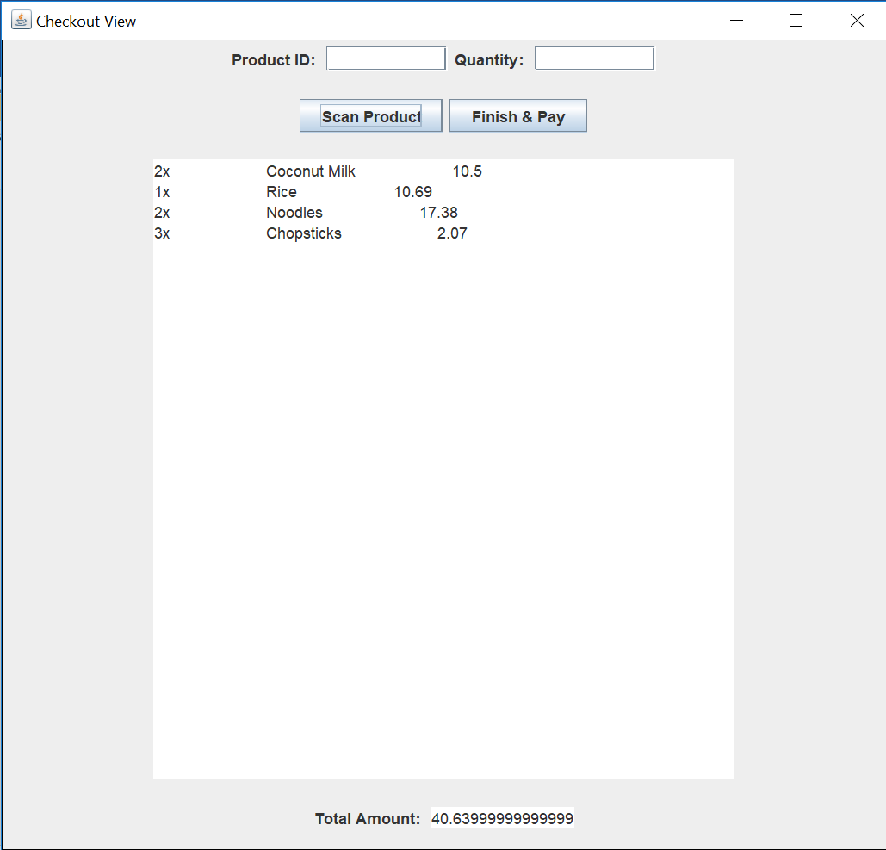

Step 5: Select “Finish & Pay” which will take you to a screen where you can select a payment type

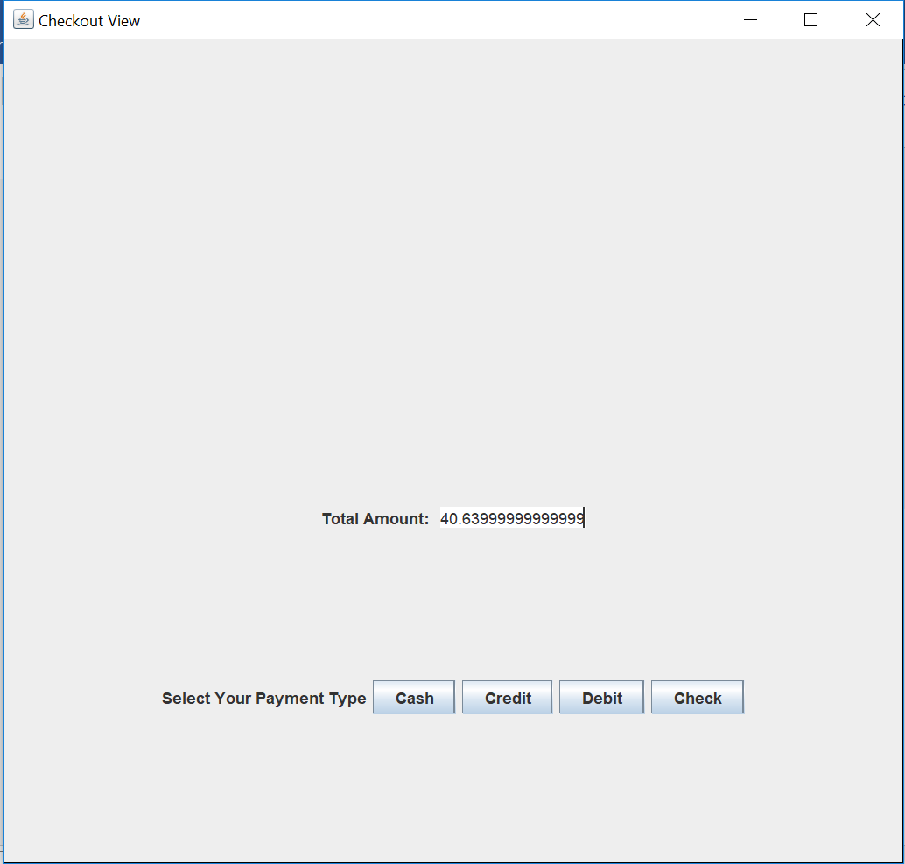

Step 6: Select payment type and the screen will exit, confirming successful payment

Step 7: To make sure that the order has been process we can check the database to see that the order has been stored

